## Problem 1 – Soap Film

The cost function I used:

**function [E] = soapFilmCost(Z)**

**c1 = 6; c2 = 5;**

**a = Z(1); b = Z(2);**

**E1 = abs(a*cosh(-b/a) - c1);**

**E2 = abs(a*cosh((5-b)/a) - c2);**

**E = E1 + E2;**

**end**

>> [m,n] = fminsearch(‘soapFilmCost’,[1,1])

m =

4.7255 3.3970

n =

4.9984e-05

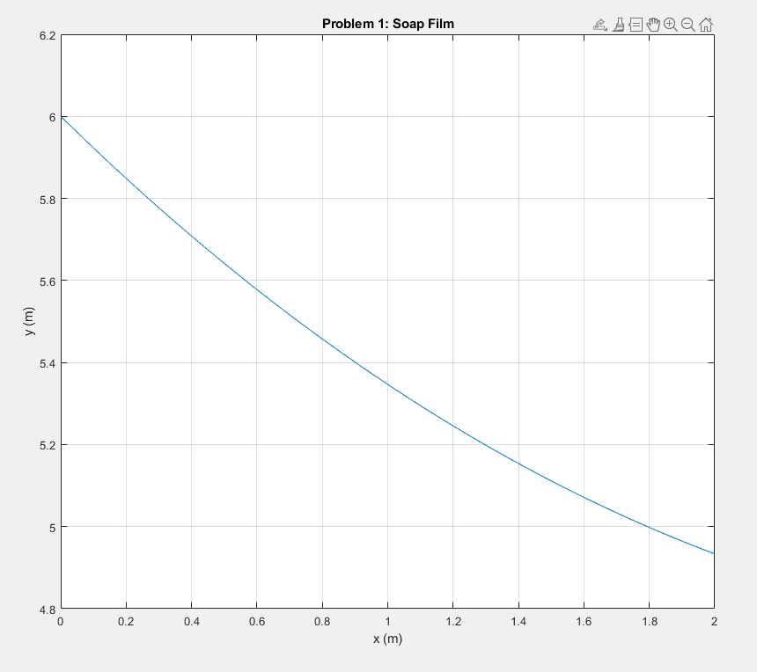

## Problem 2 – Soap Film

>> f = @(a) a.*cosh(-1./a);

>> e = @(a) abs(f(a) - 6);

>> [m,n] = fminsearch(e,4)

m =

5.9152

n =

3.6615e-05

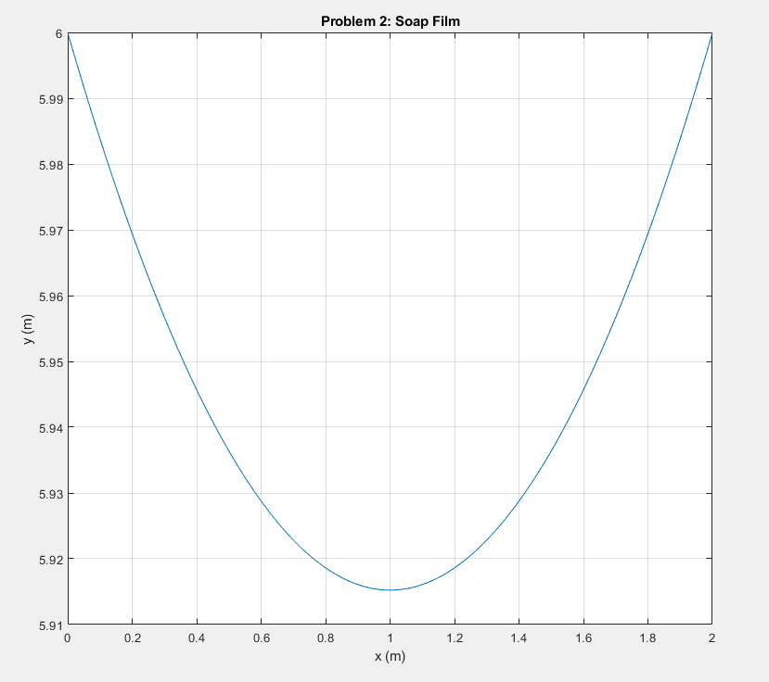

## Problem 3 – Hanging Chain

**function J = cost3(z)**

**% ECE 463 lecture #23**

**% Calculate the shape of a soap film**

**a = z(1);**

**b = z(2);**

**M = z(3);**

**% assume gravity is in the -y direction**

**% y = f(x)**

**Length = 4;**

**x1 = 0;**

**y1 = 6;**

**x2 = 2;**

**y2 = 5;**

**e1 = a*cosh((x1-b)/a) - M - y1;**

**e2 = a*cosh((x2-b)/a) - M - y2;**

**e3 = a*sinh((x2-b)/a) - a*sinh((x1-b)/a) - Length;**

**x = [x1:0.001:x2]';**

**y = a*cosh( (x-b)/a ) - M;**

**% plot(x,y);**

**% xlim([x1,x2]);**

**% ylim([0,2]);**

**% pause(0.01);**

**J = e1^2 + e2^2 + e3^2;**

**End**

>> [m,n] = fminsearch(‘cost3’,[1,2,3]);

m =

0.4717 1.1205 -3.4415

n =

1.2132e-08

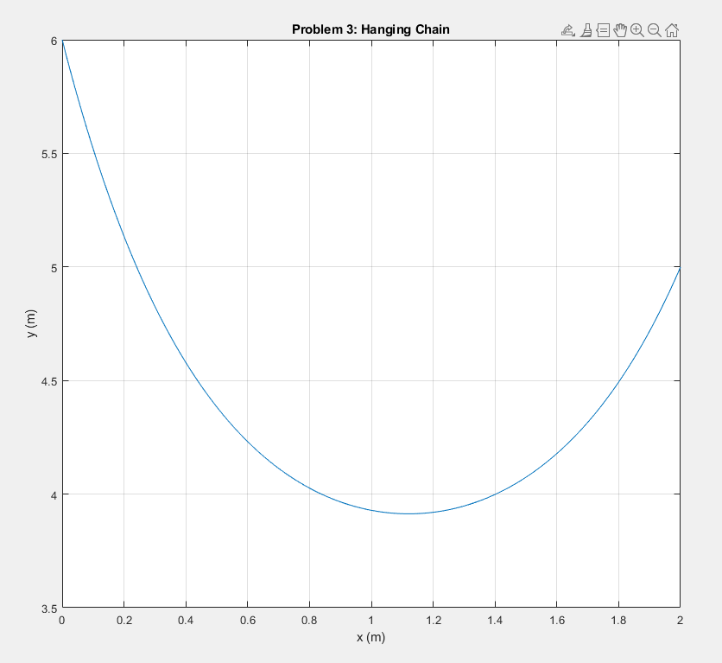

## Problem 4 – Ricatti Equation

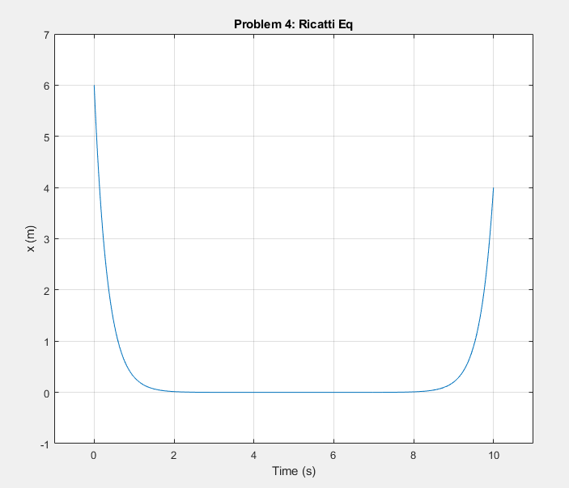

## Problem 5 – Ricatti Equation

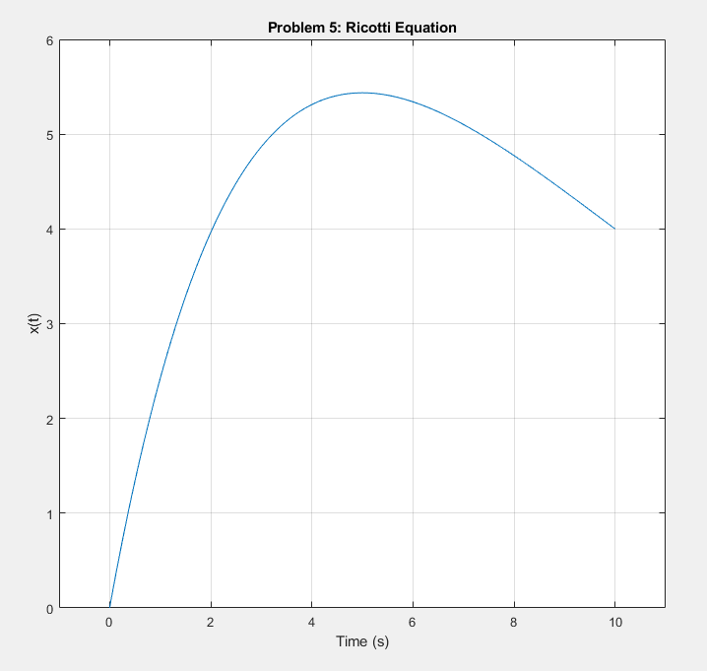

## Problem 6 – LQG Control – Cart & Pendulum

**function [A,B] = linearizedCartPend(mcart, mball, L)**

**g = 9.8;**

**A = [0 0 1 0; 0 0 0 1; 0 (-mball*g/mcart) 0 0; 0 ((mcart+mball)*g/(mcart*L)) 0 0];**

**B = [0;0;1/mcart;-1/(mcart*L)];**

**end**

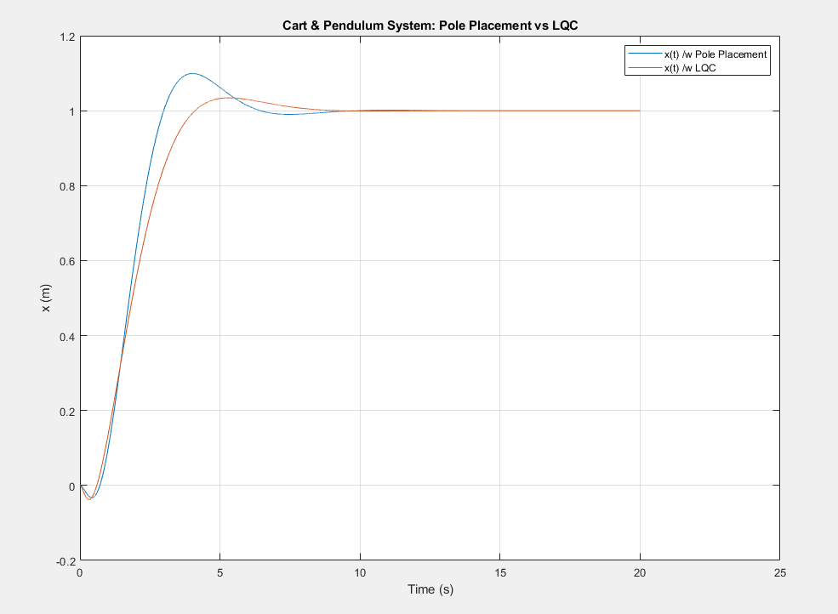

## Problem 7 – LQC Control – Ball & Beam

